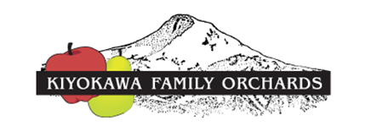
8129 Clear Creek Road, Parkdale, OR 97041
www.kiyokawafamilyorchards.com

Apples and Pears Fundraiser
Where Fundraising with Fruit is Fun!
Fresh Picked Apples and Pears from the Hood River Valley

ORDER FORM

APPLES (20-22 lbs. per box)
Mixed premium apple boxes contain 4-5 ea. Fuji, Gala, Braeburn, Granny Smith, Jonagold, Cameo, Ambrosia & Sonata

Red Ruben ________ boxes @ $________ ea. = $________
Jonagold ________ boxes @ $________ ea. = $________
Gala ________ boxes @ $________ ea. = $________
Fuji ________ boxes @ $________ ea. = $________
Ambrosia ________ boxes @ $________ ea. = $________
Newton Pippin ________ boxes @ $________ ea. = $________
Cameo ________ boxes @ $________ ea. = $________
Honeycrisp ________ boxes @ $________ ea. = $________
Crimson Crisp ________ boxes @ $________ ea. = $________
Mtn Rose ________ boxes @ $________ ea. = $________
Mixed Premium ________ boxes @ $________ ea. = $________

PEARS (22-25 lbs. per box)
Mixed boxes contain 4-5 Green D’Anjou, Comice, Bosc, Packham Triumph & Taylor’s Gold

D’Anjou ________ boxes @ $________ ea. = $________
Bartlett ________ boxes @ $________ ea. = $________
Mixed Premium ________ boxes @ $________ ea. = $________
Mixed Asian ________ boxes @ $________ ea. = $________

